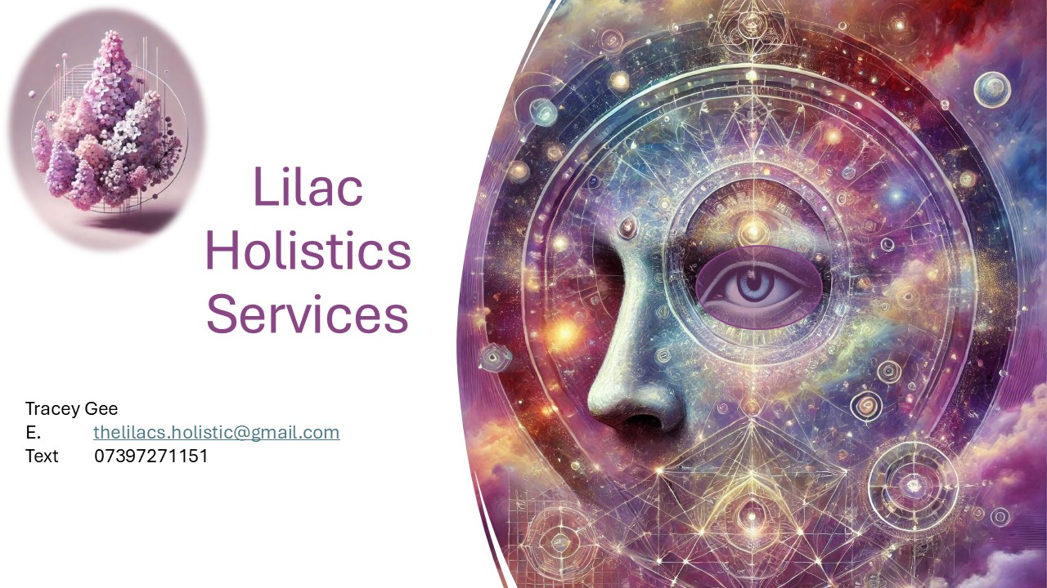

Group Party Booking Options

A message from Tracey
Thank you so much for enquiring about my group party services.
These gatherings are a wonderful way to celebrate and connect—whether it’s a get-together, an alternative birthday, anniversary, divorce party, baby shower, or simply a friends and family night with a twist.
I also offer larger-scale evenings in venues for charity fundraisers and special events. If you’d like more details about these options, please don’t hesitate to contact me.
May your days be filled with love, laughter, and abundance.
Tracey
📱 07397 271151 (text/WhatsApp)

🎉 Party Options

Option 1
- Group size: Minimum 3, maximum 6 people
- Format: 30-minute one-to-one readings in a private room within your home
- Cost: Charged per person, plus a one-off travel expense (if applicable)

Option 2
- Group size: Minimum 7, maximum 10 people
- Format: 30-minute one-to-one readings in a private room within your home
- Cost: Charged per person, plus a one-off travel expense (if applicable)
- Bonus: The homeowner/party organiser receives their reading free of charge

Option 3
- Group size: Minimum 10 people
- Format: Group demonstration with short 5–10 minute readings within your home
- Cost: Hourly rate, plus a one-off travel expense (if applicable)
- Booking limit: Maximum 2.5 hours
- Note: Not everyone is guaranteed a reading unless sufficient time is booked for the number of guests attending

🚗 Travel Expenses
Travel costs are additional to the reading fees. A quotation will be provided based on your chosen option and location.
- Within 5 miles of Chasetown, Burntwood: No travel charge
- Over 5 miles: 45p per mile to cover travel costs

